Aqualog Protocol for CDOM and FDOM Analysis

Modified from: Osburn Lab Protocol Version 12 Dec 2017 JDK &

USGS Appendix 1. Open File Report 2018-1096 Modified June 21 2018

Initial Preparations:

**Note: Always wear gloves when handling cuvettes or any samples for Aqualog**

Day of:

1. **Insert the USB key** into the USB hub located between the Aqualog and the computer. Make sure the USB button is pressed and the key light is red. USB key must be inserted or program will not work.
2. **Warm up Aqualog:** Turn on the Aqualog and allow to warm up for **1 to 1.5 hours** before running samples, using the switch located on the left side, toward the back. It may be necessary to warm up the Aqualog for a longer period of time, depending on the lamp age.
3. Record “instrument on” time in the notebook stored in the drawer underneath the Aqualog computer. At the end of the day, record “instrument off” time and record total lamp hours for the day and cumulative lamp hours. Add 1 hour to the daily lamp hour total to account for lamp ignition that is equivalent to about 1 hour of use.
4. Remove samples from the refrigerator and allow them to warm to room temperature while instrument is warming up.
5. Create standard reference material (1% SRMtea in organic free water): 1mL Tea to 99mL fresh DI water or 250 µL to 24.75 mL DI.
6. Rinse and fill DI squirt bottle with fresh DI. Allow DI water to run for ~ 2 minutes prior to filling squirt bottle.
7. Prepare Aqualog cuvette: retrieve from the laminar flow fume hood in 126 or in its case in the drawer below the Aqualog. Acid wash if necessary.
8. Turn on the computer (if not already on).
9. Log into the Aqualog 800 user on the computer.
10. Open the Aqualog software (Aqualog V4.0) located on the desktop of the computer. This will open a pop-up that asks if Origin86.exe is allowed to make changes to the computer. Click yes.
11. Lamp Test – *Daily*

Data identifier: LampDDMMMYY (eg. 06Jun22 for June 6, 2022)

*This test provides a daily view of the maximum lamp intensity and will help provide indications of deterioration as the lamp ages.*

1. This test should be run with an empty sample compartment. Prior to running this test, remove the Starna Standard Raman water sample from the compartment if it has been left there.
2. Be sure the chamber lid is closed
3. Click on the blue H2O button (page1image1785920) located on the menu bar



1. Click the 2D button on the pop up window
2. Click the ‘Absorbance’ option
3. Change the wavelength range to 700 x 1 x 200 nm
4. Enter the Data Identifier listed above
5. Choice the ‘Blank Only’ Option
6. Click Run
7. Once the test is over, when prompted, select the location to save the files in under the “Aqualog 800 Data” folder, in the appropriate year and month projects folder. Create a new folder for each day (and subfolders per project, if needed). (e.g. Aqualog 800 Data > 2019Projects > Febuary2019Projects > 01Feb2019). Save the project file as follows: DDMMMYY_InstrumentChecks
8. Plot a graph of this scan by highlight columns B and D on the data output table
9. 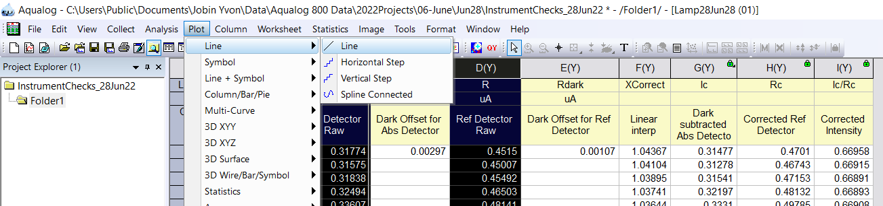From the menu bar, click the following sequence: Graph 🡪 Plot 🡪 Line 🡪 Line
10. Use the *data reader* tool and click at the tip of largest peak on the red line. Record the wavelength (x) and absorbance reading (y). If necessary, you may use the zoom feature to zoom in closer so that the peak is more easily identifiable. The peak should read an x‑value of 467 nm. The absorbance reading should be above 6. If lower than 6, alert Alan Roebuck or Allison Myers-Pigg. Do **NOT** proceed forward with scans. There are some slight daily variations in the daily absorbance value. Compare this number with the most recent scans. If these are considerably off (e.g. more than 0.2 units), allow the instrument to warm up another half hour.

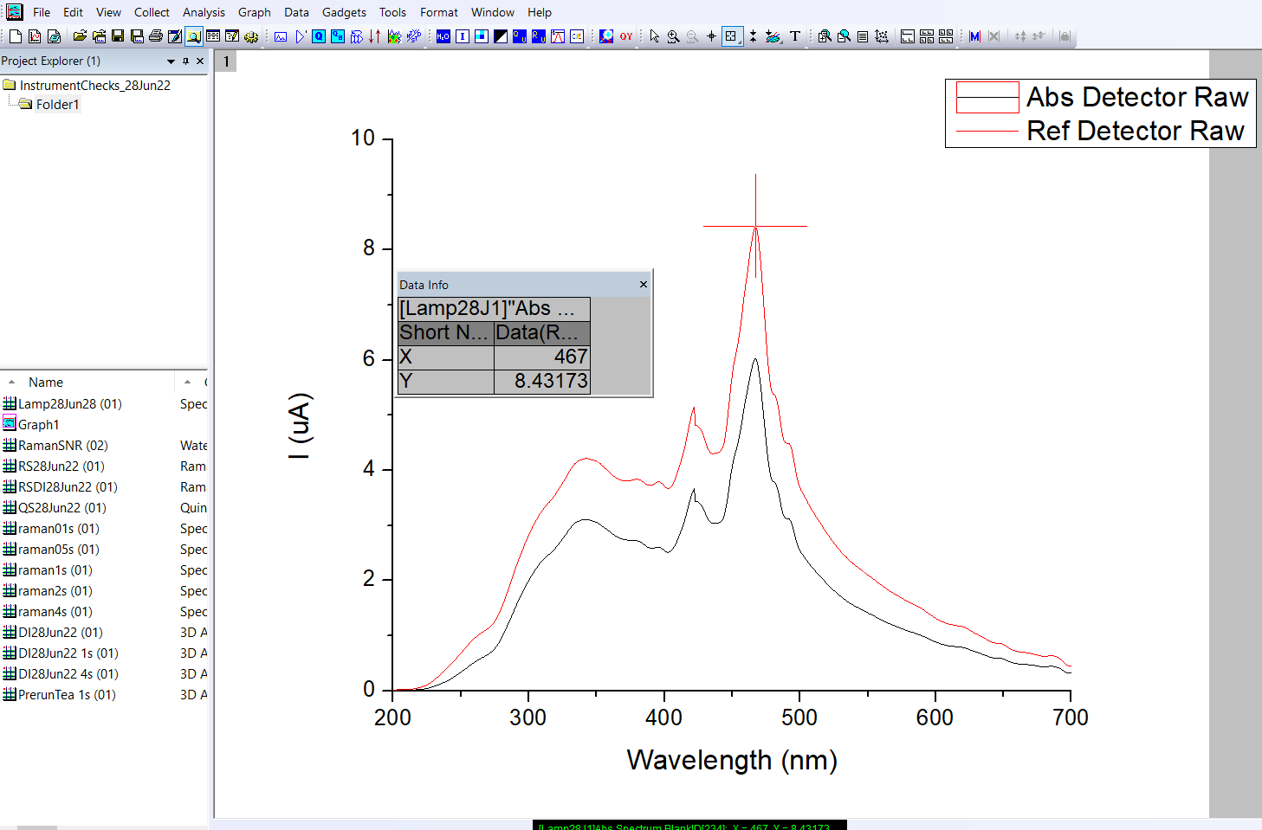

1. Record the wavelength and absorbance on the Aqualog Instrument Checks sheet and ensure this is taped into the Aqualog Lab Notebook.
2. Water Raman SNR and Emission Calibration Test ‐ *Daily*

*The calibration test integrates for a longer time period and provides a peak center and signal-to-noise ratio.*

Data identifier: RSNDDMMMYY

1. Insert the Starna Standard Raman water sample in holder into the sample compartment located on top of the Aqualog.
2. Close the sample compartment lid.
3. In the Aqualog main window, select Collect.
4. Choose Aqualog Service Only Menu.
5. Choose Water Raman SNR and Emission Calibration.
6. In the Experiment setup window fill out Data Identifier (RSN***date*** e.g., RSN01Feb19).
7. Click the Run button.
8. If the test shows a “Pass” value, continue to the next test. If test shows a “Fail” allow instrument to warm up longer (~10-20 minutes) and rerun test. If the test repeatedly fails, contact Allison Myers-Pigg or Alan Roebuck; the instrument service department will likely need to be called.
9. Log parameters from pass/fail in the Aqualog Instrument Checks sheet in the Aqualog Lab Notebook.
10. Raman Scattering Area Unit Tool (RU) ‐ *Everyday*

Data identifier: RSDDMMMYY

1. Continue with the Starna Standard Raman water sample in the sample compartment for this step.
2. Close sample chamber lid.
3. Click on the Raman Scattering Area Unit button (blue RU button) located on the menu bar under ‘Gadgets’.



1. In the experiment setup window, adjust the following:

**NOTE**: It is **very important** that the Increment and CCD gain settings match the settings that will be used for your samples for correct normalization. Integration time can be adjusted later.

* 1. Integration (s): 10 (from 30, so it doesn’t max out)
  2. Increment (nm): 2.33 nm/ 4 pixels
  3. CCD gain : Medium. (this works for most samples)
     1. Low – for really concentrated, high CDOM samples
     2. Medium – for most samples
     3. High – for really dilute, oceanic, low CDOM samples.
  4. Data Identifier: RS***date*** (e.g., RS28May16)

*\*Note: The 2.33 nm/4 pixels and Medium gain is standard across all samples ran at MCRL. Protocol is to do all instrument checks under these conditions first. If problematic samples are identified where gain needs to be changed, then these tests can be re-run to match the same sample conditions. Note, however, gain should only be altered as a last resort. Other options for problematic samples are discussed in more detail later in the document.*

1. Click Run.
2. The RU scan should look like this:

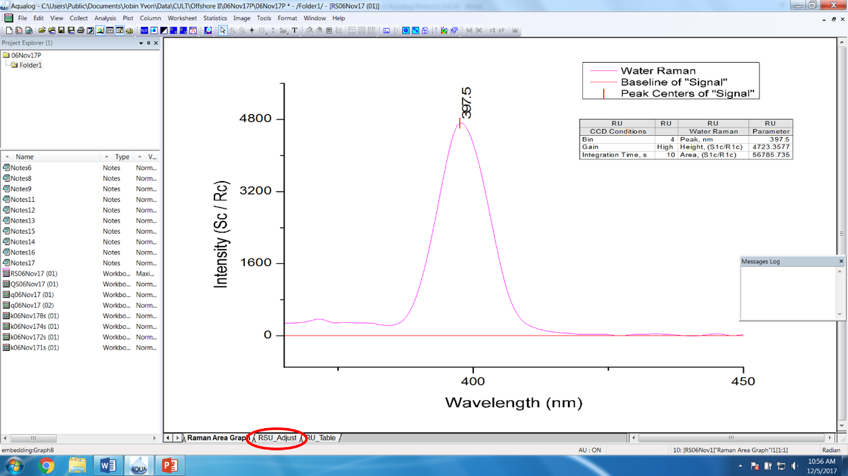

1. While the test completes, fill out the Aqualog Notebook with sample conditions (integration time, increment, and CCD gain) along with peak wavelength and peak area for 1 s integration time:
   1. The peak wavelength should be 397 ± 1 nm.
      1. This lamp usually has a peak wavelength of 397 nm (see screen shot above). (Note 11/1/2021, the peak wavelength has tended towards 398 nm lately, and has failed at 398.5 quite often).
      2. If peak wavelength is out of this range, allow for lamp to warm up for ~10 more minutes. If spectrum is not peak shaped, lamp may be dead. If there are any other anomalies on the graph, check the cuvette for any dust particles.
   2. Click on the RSU Adjust tab (circled in Red above) and record the RSU Adjust Area for 1 s integration time (circled in Red below: the time should automatically be set for 1 s, verify by ensuring Integration Time column C(Y) says 1s).

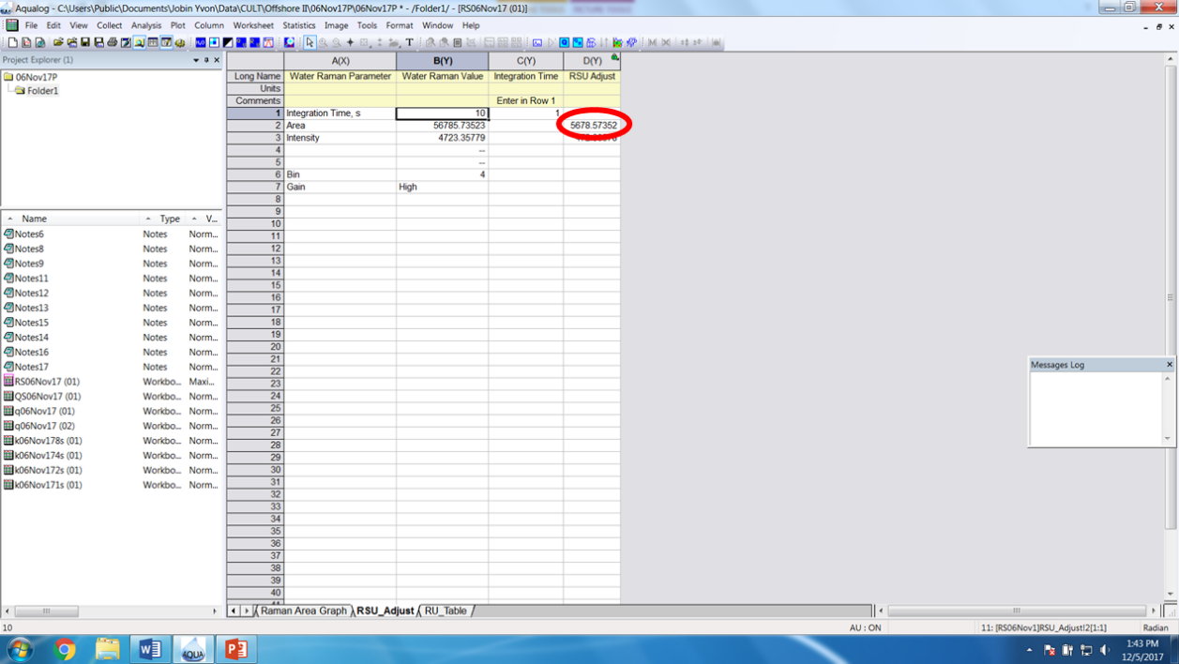

B2) Raman (Normalization) Area for Sample Blank:

*Tests to make sure cuvette and blank are clean.*

Data identifier: DIRSDDMMMYY

1. Prepare sample cuvette for running a blank
   1. Rinse cuvette 20x with DI water and fill to about 2/3 full with DI water (3 mL).
   2. **Carefully**, wipe the outsides of the cuvette with a kimwipe to remove any excess water that may have spilled to the outer side of the cuvette. If any spots, streaks, fingerprints, etc remain visible, remove these using ***lens paper***.
2. Remove Starna Standard Raman water sample in holder from the sample compartment located on top of the Aqualog and insert the sample cuvette holder. The entire holder apparatus pulls out from the front of the instrument with the top open. Unscrew the brass screws, remove the Starna Standard Raman water sample in holder and place the sample cuvette holder, hand tightening the brass screws. Make sure the black windows meet at the back left corner (ie. each line up with an instrument window). Replace the holder apparatus.
3. Insert the cuvette containing the blank solution into the sample compartment.
   1. Make sure to insert the cuvette the same way each time (e.g., the Q marks on the cuvette always facing left).
4. Close the lid of the sample chamber.
5. Rerun the Raman Scattering Area test using the cuvette filled with DI water (at least 18 meq-Ω). Make sure to use a quartz cuvette with no frosted sides, as glass and acrylic cuvettes can impair UV fluorescence and cause filtering effects.
6. Click on the Raman Scattering Area Unit button located on the menu bar.
7. In the experiment setup window, adjust the following:
   1. Integration (s): 10
   2. Increment (nm): use same as for Raman Scattering above (e.g. 2.33nm/4 pixels)
   3. CCD gain: use same as for Raman Scattering above (e.g. Medium)
   4. Data Identifier: DIRS***date*** or kRS***date*** (e.g., DIRS01Feb19 for DI water)
   5. **NOTE**: **The Increment and CCD gain settings need to match the settings that will be used for your samples.** Integration time can be adjusted later.
8. Click Run.
9. When the test completes, fill out the Aqualog notebook.
   1. The peak wavelength should be 397 ± 1 nm.
   2. Click on the RSU Adjust tab and record the RSU Adjust Area for 1 s integration time.
10. *Compare the RSU Adjust area for your blank with the Raman Scatting Adjust area, these two values should be close to one another*.
    1. % Difference = (Starna Raman Water RSU Adjust Area- DI RSU Adjust Area) / Starna Raman Water RSU Adjust Area X 100%
    2. *Record the difference in the Aqualog Notebook*. If the two values differ by more than **~1%**, clean the cuvette and fill with fresh DI and rerun test if using this value to normalize your data.
11. Saving and exporting the water Raman file:
    1. The water Raman data file should be exported as a .dat file.
    2. Activate the worksheet entitled “**Emission Sample Data**”
    3. Select File from the drop-down menu, then Export, then ASCII.
    4. Rename the worksheet to “DIRSMMDDYY_Emission Sample Data” (e.g. DIRS051816_Emission Sample Data).
    5. Export to the Export Data folder that you create for this run date. e.g. Aqualog 800 Data\2019ExportData\Febuary2019ExportData\01Feb2019\DIMMDDYY_ Emission Sample Data.dat.
    6. Upon export screen, verify that you are exporting everything you want in the correct file type
       1. Check name, units, comments, precision, etc – the default checks are usually fine.

B3) Quinine Sulfate Units

1. Add the Starna Quinine Sulfate blank into the cuvette holder in the sample compartment. The sealed quinine sulfate blank and sample solution are located in a wooden box in the drawer below the Aqualog.
2. On the main toolbar, click the Quinine Sulfate Units button (blue button with QU).



1. In the experiment setup window, adjust the following :

**NOTE**: The Increment and CCD gain settings need to match the settings that will be used for your samples. Integration time can be adjusted later.

* 1. Integration (s): 0.05 (from 0.1)
  2. Increment (nm): use same as for Raman Scattering
  3. CCD gain: use same as for Raman Scattering
  4. Data Identifier: QS***date*** (e.g., QS28May16)
  5. Select Sample and Blank > Collect Blank
     1. Choose the appropriate folder to save the blank file and save as QSB***date***.blank (e.g., QSB28May16.blank). This should be the folder for the day in your project and personal folder. The blank file needs to end in ‘.blank’ or you will get an error when you click Run.

1. Click Run.
2. Ensure the quinine sulfate blank is in the sample compartment and press OK in the Experiment Paused window.
3. When prompted, switch the blank for the Quinine Sulfate sample cuvette and click OK in the Experiment Paused window.
4. Spectrum of the quinine sulfate reference should look like this:

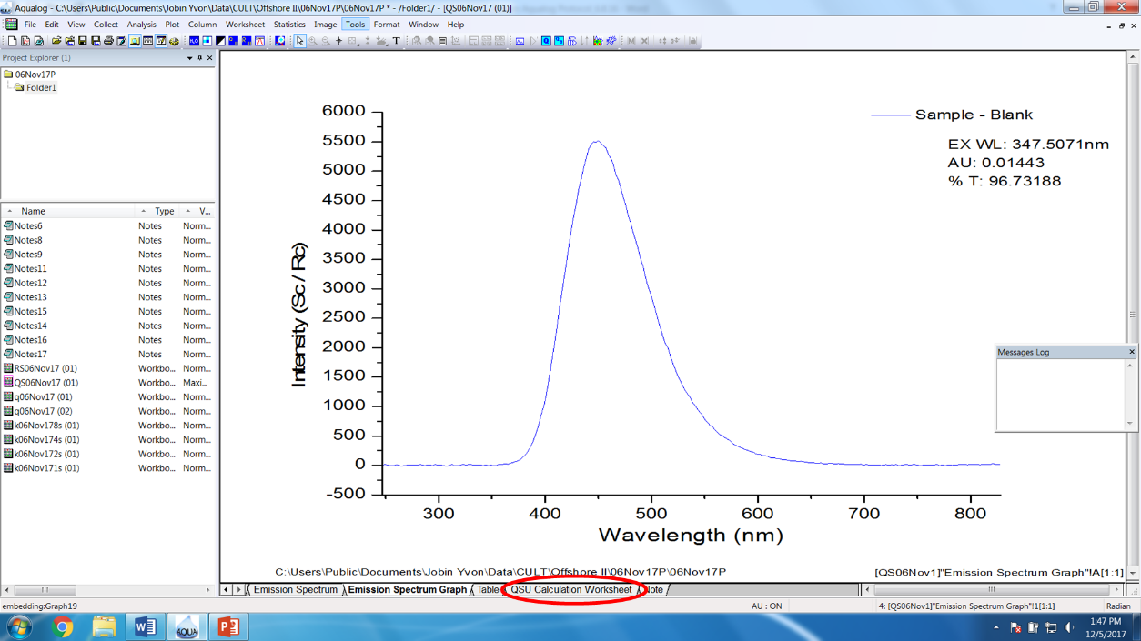

1. When the test completes, fill out the Aqualog log with sample conditions (integration time, increment, and CCD gain) along with peak wavelength and peak area for 1 s integration time:
   1. Click on the QSU Calculation Worksheet tab, expand the G(Y) column for QSU Adjust to view the actual value instead of #####, and record the QSU Adjust Area for 1 s integration time.

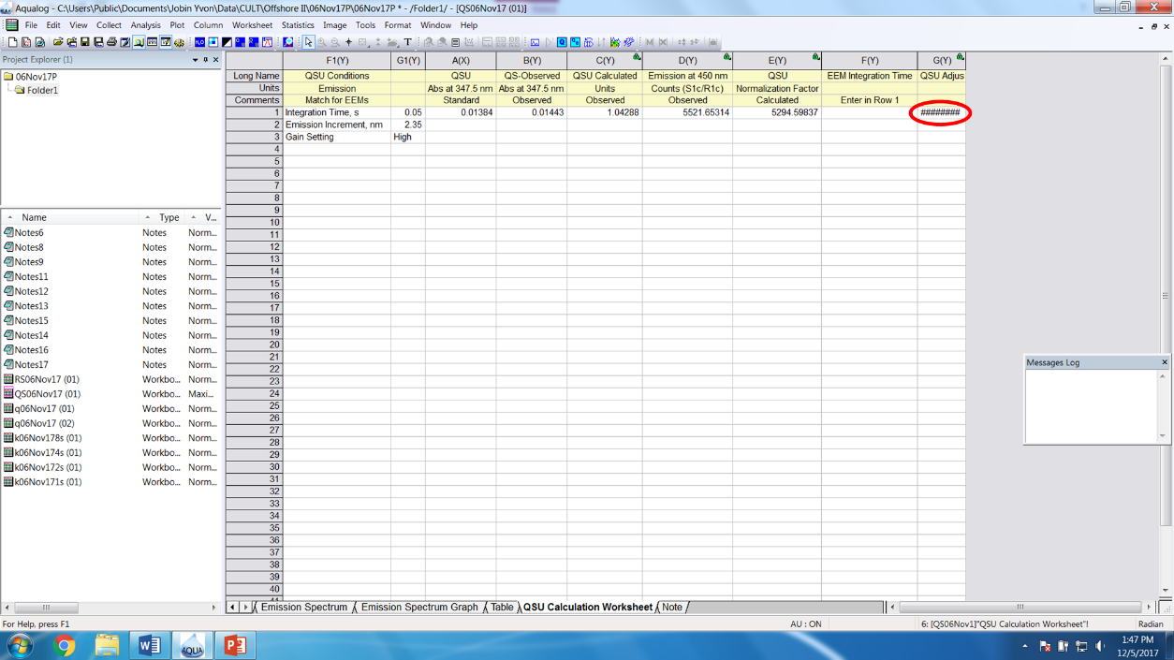

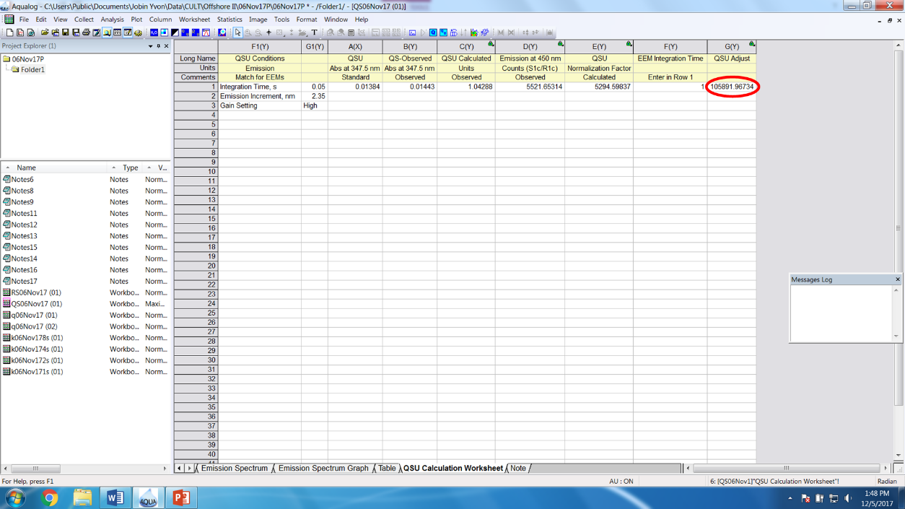

1. Collect a sample blank:

Data identifier: DIDDMMMYYIT

IT=integration time (e.g 1s)

1. Collect a blank scan

**NOTE**: All blanks need to be collected prior to running samples. Run blanks for all integration times that will likely be needed for the day prior to starting sample analyses. Common integration times include 0.1, 0.5, 1, 2, and 4 seconds.

***The blank scan can be performed using the DI water in the cuvette for the water Raman test, assuming the RSU Adjust was within 1% of the Raman Water Standard.***

1. Press the Experiment Menu button (blue button with H2O page1image1785920) on the menu bar in the Aqualog’s main window or select Collect > Aqualog Main Experiment Menu.



1. Select 3D to run Excitation Emission Matrix plus Absorbance
2. Choose Emission CCD + Absorbance in the Aqualog Experiment Type window and click Next.
3. In the Aqualog Experiment Setup widow, click Load to select a saved method: Methods/method_01s.xml (01s indicates an integration time of 0.1 seconds. 1s, 2s, and 4s indicate integration times of 1, 2 and 4 seconds, respectively).
4. Methods should be saved to standard sample configurations for MCRL. However, **ALWAYS DOUBLE CHECK!** This includes Check to make sure the Wavelength Settings are appropriate for the desired method and match settings to be used for the samples:
   1. Integration time: Should match the open method (0.1 for 01s, etc…)
   2. Excitation Wavelength: High = 800 nm, Low = 230 nm, increment = 3 nm
   3. Emission Coverage: This cannot be changed. High = 828.03 nm, Low = 246.55 nm
   4. Increment: Needs to match the settings used for RSU and QSU (2.33nm/4 pixels)
   5. CCD gain: Needs to match the settings used for RSU and QSU (Medium)
   6. Data Identifier: DI***date****integrationtime* (e.g., DI01Feb19 1s for DI water with integration time of 1 sec, use 01 for 0.1s as decimal and special characters cannot be used when naming files).
   7. Select Blank Only.
      1. Choose the location to save the blank file by clicking the ‘…’. This is typically the folder for the day in your project folder. The blank file should be named the same as the data identifier and end in ‘.blank’. However, please be as descriptive as possible with the blank file name and make the date as unambiguous as possible. This is not limited by character numbers, so can be more descriptive than the sample identifier, if necessary. (e.g. DIBlank01Feb19_1s.blank for DI water with integration time of 1s)

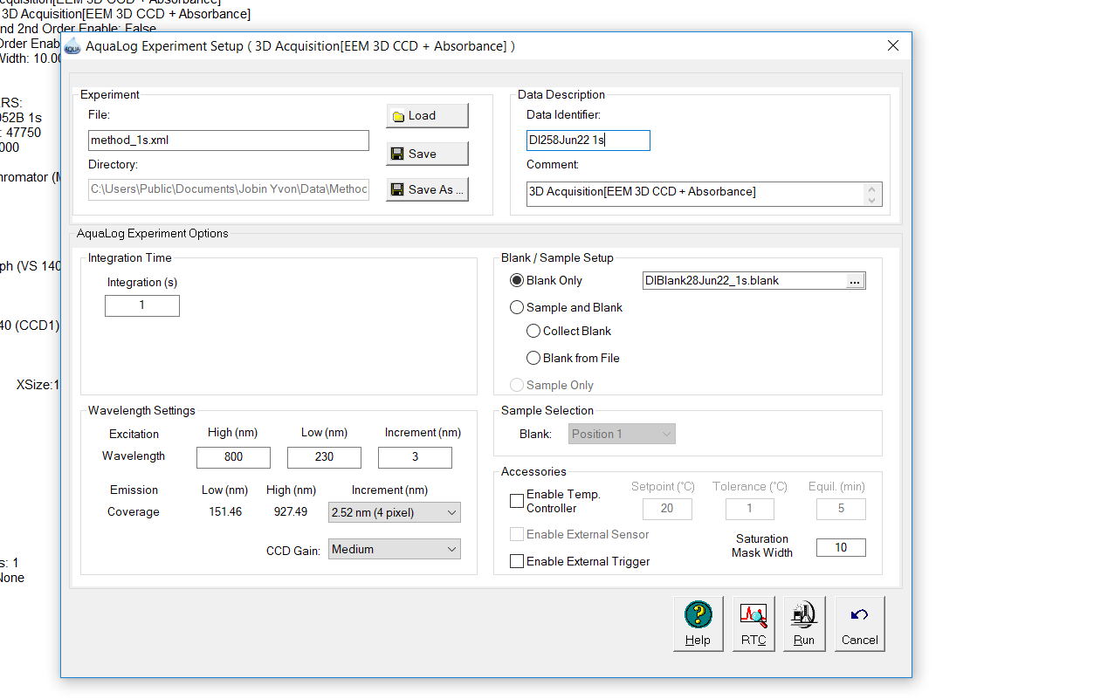

1. Ensure cuvette with blank sample is in the sample compartment.
2. Click run.
3. The Intermediate Display window will appear and show an absorbance spectrum followed by the EEM as it is collected.
4. When scan is complete, the emission spectrum window appears. Make sure that your blank looks clean and free of unexpected peaks. Clean cuvette and rerun blank if needed.
5. A clean blank should be free of extra, stray peaks other than the Raman and Rayleigh scattering peaks. See Examples below.
6. Repeat this step to record a blank at each integration time you may consider running sample at (0.1, 0.5, 1, 2, or 4). ALWAYS Run at 0.1 seconds as this is used for an exploratory step.

**Waterfall Plot-**

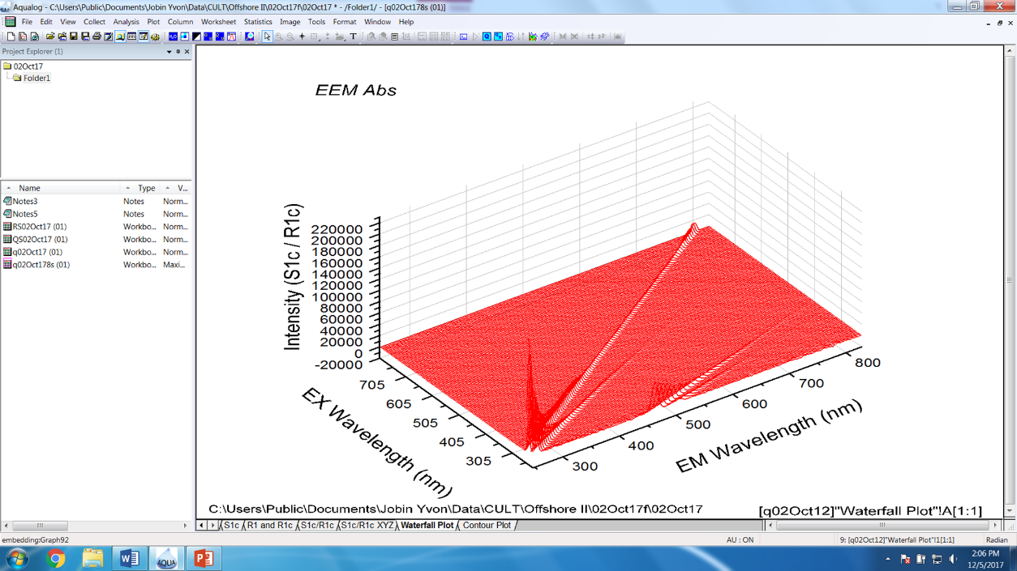

**Contour Plot-**

Example EEM of pure water with the Raman and Rayleigh scattering peaks labeled. http://dellwindowsreinstallationguide.com/steadystatefluorescencespectroscopybasics/

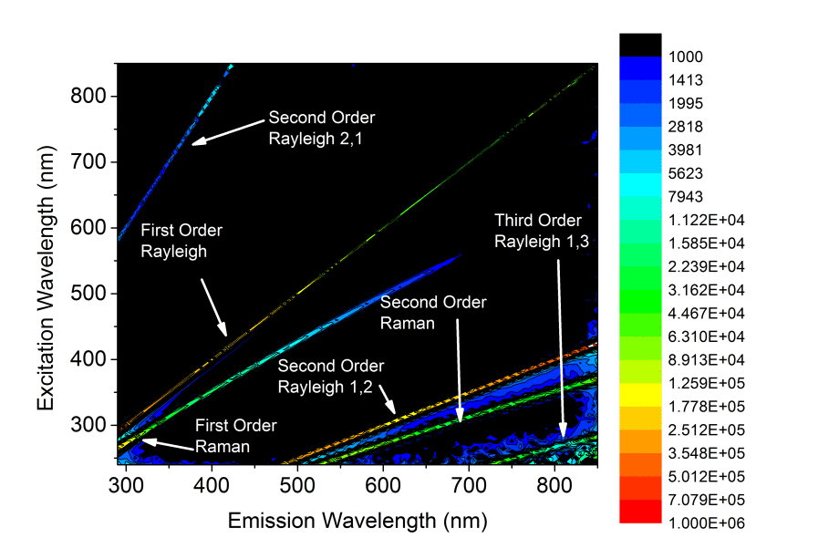

1. Run SRMTea Standard

The SRM­Tea standard is to be ran at the beginning and end of each day and is always ran at 1 second integration times.

1. Remove the cuvette from the sample compartment and dump water into waste container.
2. Using a pipette, pipette 1 mL of the SRMTea standard into the cuvette and proceed to wash all sides of the cuvette
3. Dump sample into waste
4. Pipette 3 mL of the SRMTea into the cuvette
5. Remove excess water from outsides of cuvette with a kimwipe and remove streaks and fingerprints with lens paper.
6. Add cuvette back to sample compartment with the Q facing left
7. Close sample compartment.
8. Click on the H2O button as you would for running a blank
9. Select 3D to run Excitation Emission Matrix plus Absorbance
10. Chose Emission CCD + Absorbance in the Aqualog Experiment Type window and click Next
11. Click the ‘Load’ by the method and locate the method designated for 1 second integration time. There is a Methods folder of methods pinned to the Quick Access Menu in the file explorer.
12. Confirm that the method settings are correct
13. Rename the Data Identifier as preTea01Jul19 1s or postTea01Jul19 1s.
14. Under the Blank/Sample Setup, chose the ‘Blank from File’ Option.
15. Click the 3 dots ‘…’ and locate the 1 second blank file recorded previously
16. Click Run
17. These runs will be exported at the end of the day.

*Once all instrument checks and the SRMTea standard has been ran, save the project and open a new project to begin running samples.

1. Explorative Experiment

Running a Sample. When unfamiliar with the optical behavior of your general sample sites, it is best to run an exploratory experiment to determine the optimal integration times. The same integration time can likely be applied to all samples that one would expect to be somewhat similar, whereas heavily contrasting samples (e.g. fresh vs saltwater, high vs low flow) will need multiple exploratory experiments to span the gradient of shifting optical character.

1. Prepare cuvette for running a sample
   1. Dump any previous sample into the waste container
   2. Rinse cuvette 3x-6x with DI water
   3. Shake the sample bottle to mix well
   4. Condition cuvette once with sample water (1mL rinse) and fill just over half-way with the sample (3mL)
   5. Polish cuvette sides with lens paper, ensuring it is free of spots, streaks, fingerprints, etc.
2. Insert the sample into the sample compartment with Q facing left.
3. Click the H2O button as you would for running a blank.
4. Select 3D to run Excitation Emission Matrix plus Absorbance
5. Choose Emission CCD + Absorbance in the Aqualog Experiment Type window and click Next.
6. Click “Load” by the method and locate the method with the desired integration time. For an initial exploratory run, choose **0.1s integration time.** There is a folder of methods pinned to the Quick Access Menu in the file explorer.
7. Confirm that the method settings are correct.
8. Rename the file in “Data Identifier”. Be sure to add the integration time at the end (e.g. ‘SFA001 01s’).
9. Under the Blank/Sample Setup, chose the ‘Blank from File’ Option.
10. Click on the three little dots to the right of the name and change the blank file to one from the current day, making sure to match the integration times with the right method. The program will not run if the integration times don’t match. For Explorative Experiments, chose the 0.1 second blank that was just ran.
11. If this is the first run of the day using the selected method, press save. This will update the method to the current day’s blank file. Then click run.
12. Click Run, sample will run immediately.
13. Closely monitor the live EEM generation to determine the optimal integration time for this sample:
    1. As the sample is running, look at the intensity of the EEM it produces. You should not look at the line of scattering, but at the intensity beneath it, at excitation wavelengths 250-450 nm and emission wavelengths 350-600 nm.
    2. Match the intensity to the color bar to help determine the optimal integration time.
    3. The optimal integration time is one which will give an intensity somewhere between roughly 20,000 and 30,000 units. For the example below, this would be an integration time of 2 seconds (intensity is scaled proportionally with integration time, thus the maximum of 1300 units at 0.1s will give a maximum of 26,000 at 2 seconds). An error on the instrument will be given when this number goes above 50,000 units.

* 1. Once the sample is finished, check Absorbance scan by clicking on the ‘Abs Spectra Graphs’ tab. Does it look like what a water sample should? ie. smooth decrease in absorbance from low wavelengths to high? What is the max ABS value? **If the absorbance at 254 nm is > 0.3, the sample must be diluted** to avoid secondary inner filter effects in the fluorescence spectra (e.g. reabsorption of light emitted)**.** 
     1. This can also be confirmed numerically by clicking on the ‘Abs Spectrum Sample’ tab. Wavelength is in the A(X) column while absorbance will be in the J(Y) column.
  2. Note: Integration time does not impact Absorbance graphs, only EEMs. So, an absorbance spectrum will be the same at 0.1 secs as 4 seconds.

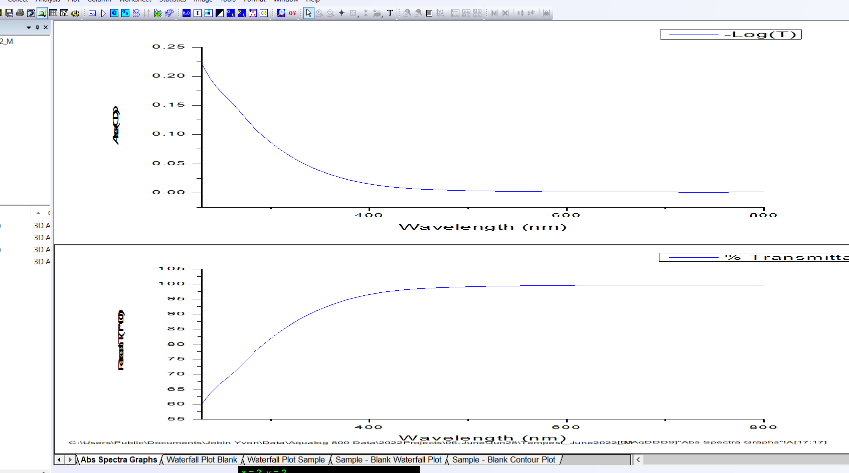

Should be **<0.3 at 254 nm**. If this not abundantly clear, numerically check by clicking on the ‘Abs Spectrum Sample’ Tab at bottom of page and finding the absorbance at 254 nm

**Note:** If this is the first sample of a project, you will be prompted to save the project as you were earlier. Save project as some identifiable project name followed by a letter

F. Sample Analysis

1. Rerun the sample by following steps 4-12 in the previous section using the method representative of the best integration time for this sample.
2. There is no need to change out a sample that was ran at 0.1 second integration times, thus the same sample as the exploratory test can be used for the primary sample analysis.
3. If a sample is ran at an integration time of 1 second or greater, a fresh sample is required should a re-run be necessary for any reason.
4. **ALWAYS** include the integration time in the Data Identifier (e.g. ‘SFA002 4s’)
5. It is strongly advised to save the project after each sample is ran with a maximum of 3-5 3D scans per project before creating a new project.
6. Record the Sample name, dilution factor, and integration time in the Aqualog Notebook.
7. Data Export

The following instructions walk you through how to export necessary files needed to get EEM data. Note that all processing and corrections are done in Matlab.

1. Open respective project file that contains data of interest.
2. On the menu bar, click File 🡪 HYJ Export
3. This opens the following box window.

1. Click on the three little dots to the right of the Export Graph(s) selection bar. This opens a new screen:

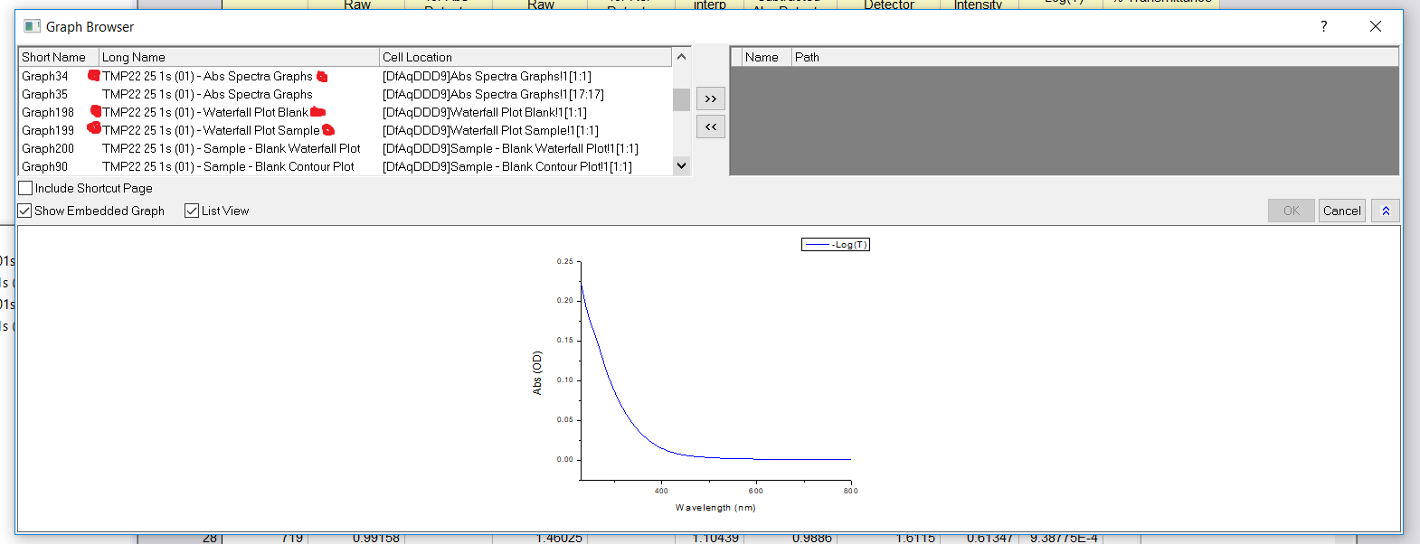

1. Be sure that ‘Show Embedded Graph’ and ‘List View’ are checked
2. Find the samples you would like to export. Each sample will have 3 files to associated with it that need to be exported.
   1. Sample – Abs Spectra Graphs
   2. Sample – Waterfall Plot Blank
   3. Sample – Waterfall Plot Sample
3. Highlight the 3 files needed for each sample and click the double right arrow. Once all files for all samples have been added. Click the OK button.
4. This returns to the previous box window above. Click the OK button.
5. You will be prompted to find a destination to save your data.
6. Navigate to the Jobin Yvon/Data/Aqualog 800 Data/2022ExportData folder and save into appropriately dated folder.
7. Repeat this process for all projects that have samples. Don’t forget to export the SRMTea standards also.
8. Save Your Results and Shutdown Aqualog:
9. Make sure your data has been properly backed‐up. You can remove data with a USB stick.
10. When finished close the Aqualog program and click Yes when asked to save changes.
11. Shut down computer.
12. Shut off Aqualog using switch on the back left-hand side.
13. Remember to finish filling out the lab notebook.